Name: Rana Ahmed SE-2

Week 1 Lab Report

Part A VM vs Container Comparison

Container Results
- Low memory usage (878 of MB)
- Very few processes
- Fast startup (<1 second)
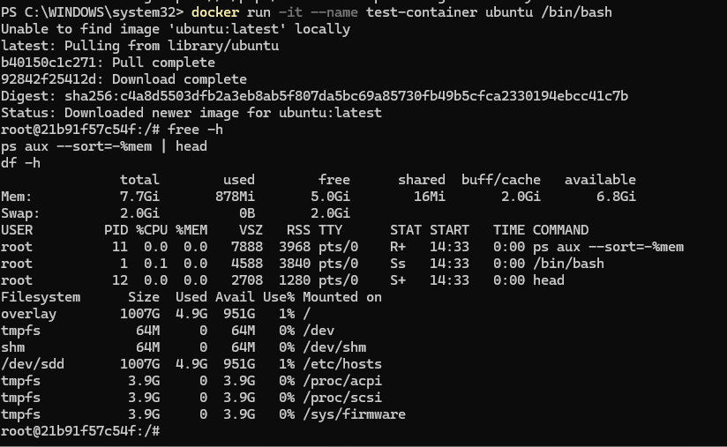

VM Results
State:
A virtual machine runs a full operating system including kernel and background services, which leads to higher memory consumption (hundreds of MBs to GBs), more running processes, and slower startup time compared to containers.

Part B — Cloud (keep as theory if you didn’t run AWS)

About AWS Nitro System
Write:
AWS Nitro System is a modern virtualization architecture that offloads networking, storage, and security functions to dedicated hardware. This reduces hypervisor overhead and improves performance and isolation.

Why AWS split Nitro into hardware?
Critical concept (likely question):
Instead of software hypervisor:
- Network → dedicated card
- Storage → dedicated card
- CPU → minimal hypervisor
Benefits:
- Lower latency
- Near bare-metal performance

C — Tail Latency
Simulate a service with random delays and observe tail latency (slow outliers)
